Name: John-David Buchanan

Date: 2023/11/24

Instructor: Louise Rennick

Advanced Java Final Project - Prototype

Objective

* Create a web application for an ecommerce site that sells hand-painted miniatures for table top gaming.

This app / site will have:

* A home page with a splash page, showing eye-catching images (possibly animated) and links to other pages (products, orders, cart, about, contact, coming soon, etc.
* A product page showing a gridded list of products, including image thumbnails, price, and buttons to add to cart or order now. A dropdown (optional) menu will provide multiple options for searching/grouping products by different categories(ie: character class/race, artist, type) . Clicking on a thumbnail will connect to a generated page displaying more details about the specific product, including: description, artist name, and multiple larger images in a carousel.
* A cart page with features that can add or remove products, delete products from cart, show an updated total of price per object (by quantity) and for total purchase
* An order page showing all the orders from the user, as well as a cancel option
* A navigation bar with all appropriate site links, and will have (optional) a dropdown feature
* A login, logout, and user registration pages
* A checkout page with (optional) 3rd party service

Tools

* Java Server Pages (JSP)
* Bootstrap, HTML CSS
* MySQL
* Tomcat
* Eclipse Workbench IDE
* JDBA
* DAO
* Servlets

**Wireframes:**

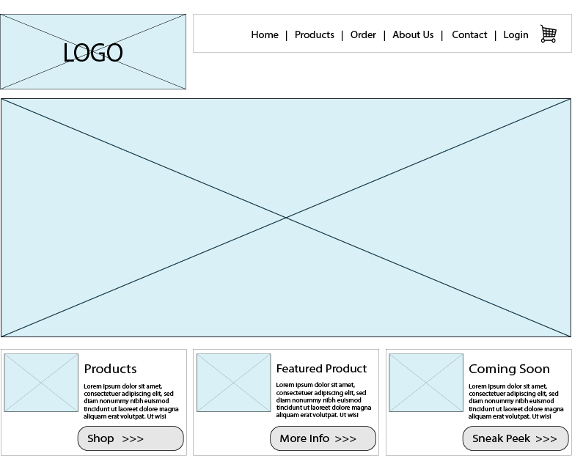

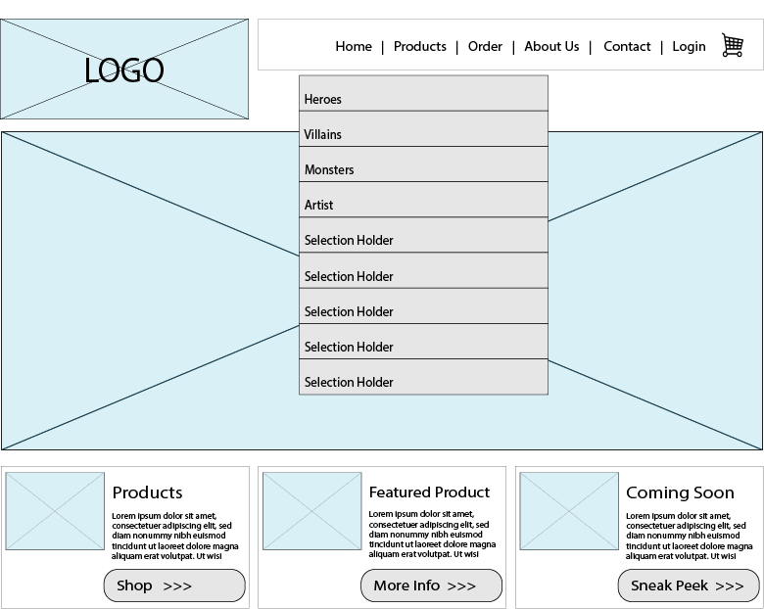

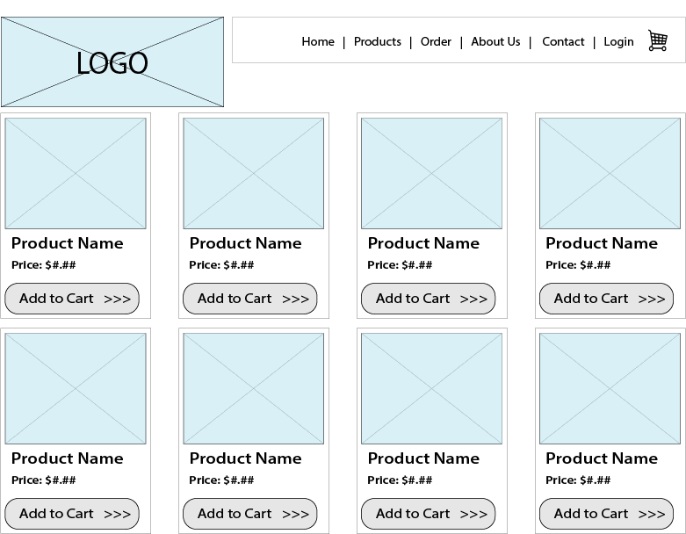

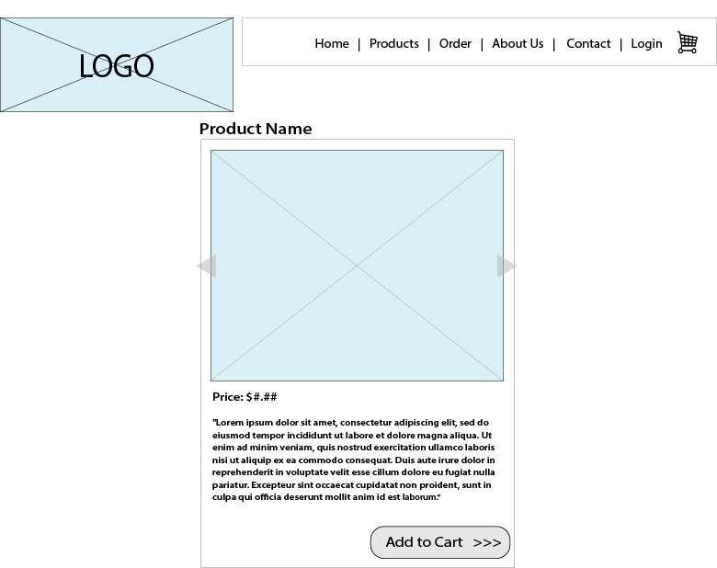

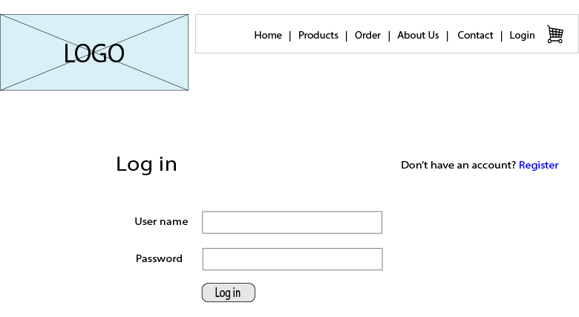

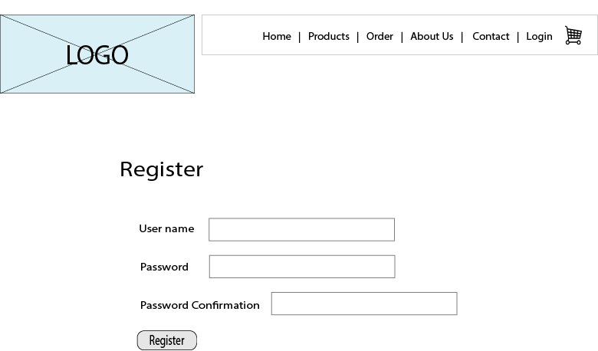

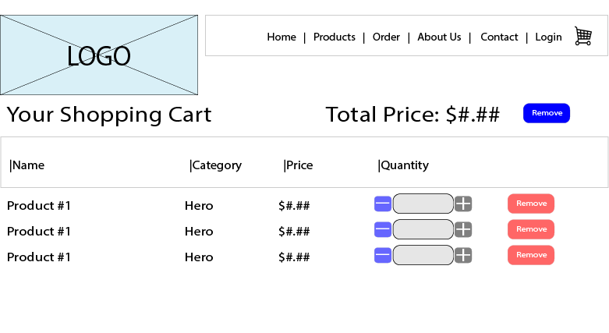

**UML**

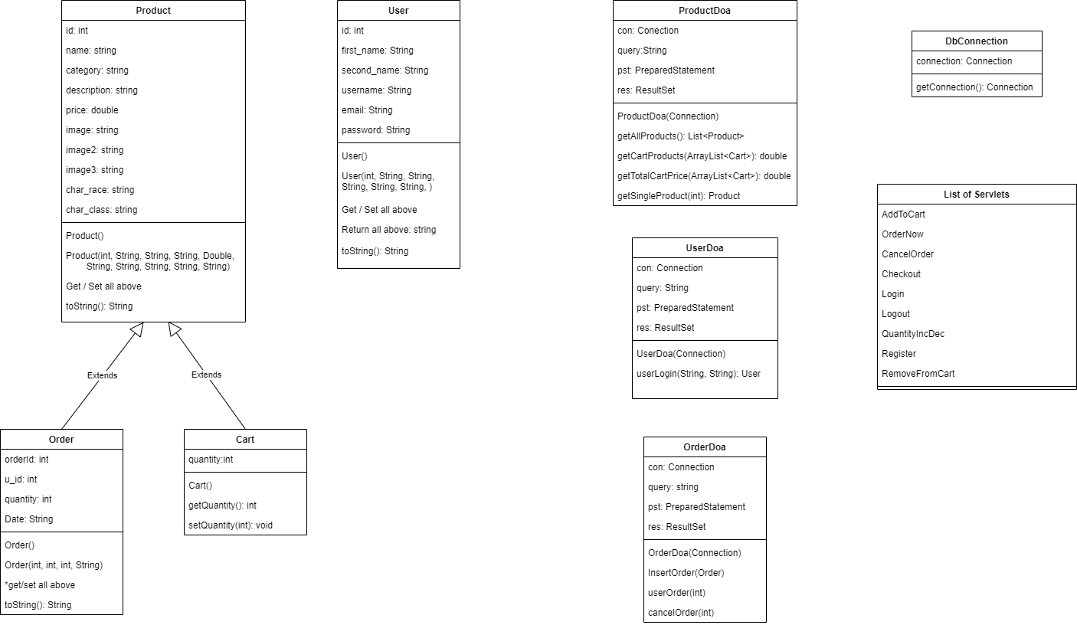

**Database:**

